TARS

INTRODUCTION
Team Name: Tars
Area: Activity Recognition and Tracking
Term Project, Machine Learning (CS60050), Autumn 2016-2017, IIT Kharagpur
Project Title: "Wand Duelling"
Project Discription: Wand dueling is a real time one vs. One spell fighting game that uses image processing and pattern recognition in order to deliver a energetic magical battle between two wizards/witches. Players have to cast offensive and defensive spells in order to win the duel, while waving the wands according to spell they are casting, as each spell has its own unique pattern. While the cameras and computer keep track of the motion of wand and it's timing.
Group Members:
Saloni Priya [14PH20031]
Baibhaw Kumar Singh
Mohit Dhariwal
Chinmaya Verma
Arpit Bansal
Tushar Kant Deo
Mukesh Chandak

THEORY

There are three types of layers in neural network.
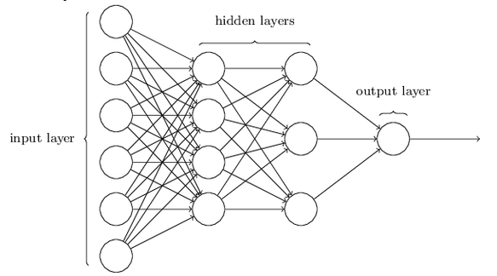

The design of the input and output layers in a network is often straightforward. For example, suppose we're trying to determine whether a handwritten image depicts a "9" or not. A natural way to design the network is to encode the intensities of the image pixels into the input neurons. If the image is a 64 by 64 greyscale image, then we'd have 4,096=64×64 input neurons, with the intensities scaled appropriately between 0and 1. The output layer will contain just a single neuron, with output values of less than 0.5 indicating "input image is not a 9", and values greater than 0.5 indicating "input image is a 9 ".
Now to recognize individual digits we use three layered network:
The input layer of the network contains neurons encoding the values of the input pixels. As discussed in the next section, our training data for the network will consist of many 28 by 28 pixel images of scanned handwritten digits, and so the input layer contains 784=28×28 neurons.The input pixels are greyscale, with a value of 0.0 representing white, a value of 1.0 representing black, and in between values representing gradually darkening shades of grey.
The second layer of the network is a hidden layer.
We denote the number of neurons in this hidden layer by n, and we'll experiment with different values for n. The example shown illustrates a small hidden layer, containing just n=15 neurons.
The output layer of the network contains 10 neurons. If the first neuron fires, i.e., has an output ≈1, then that will indicate that the network thinks the digit is a 0. If the second neuron fires then that will indicate that the network thinks the digit is a 1. And so on. A little more precisely, we number the output neurons from 0 through 9, and figure out which neuron has the highest activation value. If that neuron is, say, neuron number 6, then our network will guess that the input digit was a 6. And so on for the other output neurons.

MODEL
- The wand whose motion is to be tracked and recognised is an object with characteristic color for eg, green. The input is taken through the webcam of our computer. The wand is recognised by our programme by through image processing. One way is through color detection ie setting the Hsv value wrt to the characteristic color.
- We can set HSV limits in real time by using trackbar.
- For tacking the object we are getting live feed from our webcam which stores each frame and the coordinates of the position of wand in each frame one by one. And then it connects all the coordinates to give the path it has travelled.
- After tracking we converts the path into binary image which then gets converted into 28X28 array for identification by neural network. For training of data we use the data set provided by MNIST
(http://yann.lecun.com/exdb/mnist/). It has 60,000 test images of different digits. We use 50,000 of these images for training and rest 10,000 for validation set.
- We construct our neural network through python. we'll use stochastic gradient descent to learn from the MNIST training_data over 10 epochs, with a mini-batch size of 10, and a learning rate which we are deciding after seeing the result of various η on validation set which contains 10000 binary images. The algorithm to find the appropriate η is as follow
  - Initiate η randomly (we are using η = 1.0 in first iteration) and calculate the efficiency on validation set over 3 epochs. Let the efficiency in this case be called as c.
  - Update η->η+0.3
  - Recalculate the efficiency over validation images. Let the efficiency in this case be called as b.
  - Repeat
  - Calculate b with updated η and with each iteration c-->b
  - If b-c>80
.η--> η+(.001*(b-c))
  - If b-c>0 && b-c<80
.η-->η+(.005*(b-c))
  - If b-c==0
.η-->η+(.1)
  - Else
.η-->η+(.005*(b-c))
We choose η which we get around 95%-96% efficiency.
6. In our model each digit signifies a spell and we assign a particular strength value to each spell in order to have a comparison between different spells.
Results
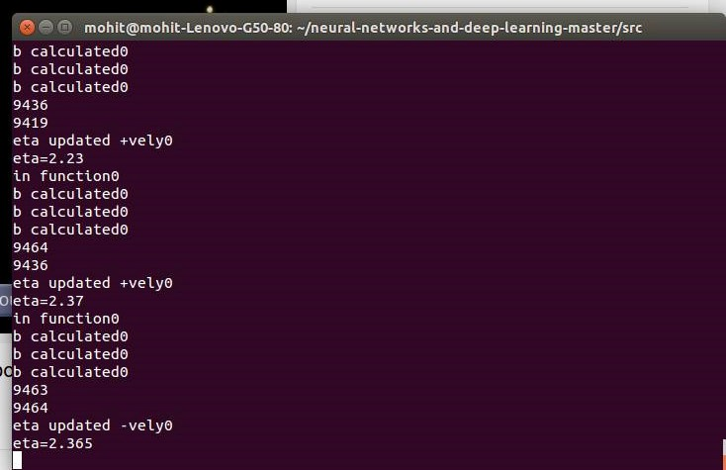
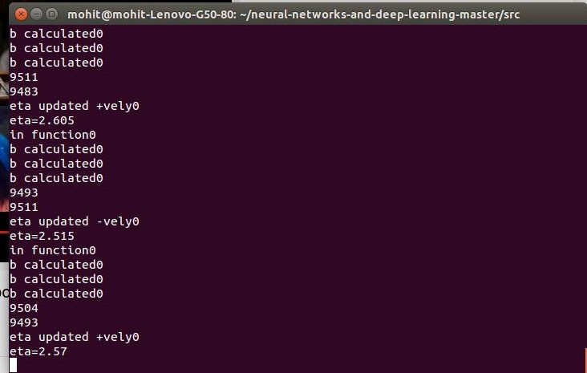
We can see that for inner layer containing 50 neurons and for 5 epochs we get η=2.605 for 95.11% efficiency. For 30 neurons and for 5 epochs we get η=3.805 for 95% efficiency.

Choice of wand
We tried different wands like light source or simple objects like toothbrushes, detection of light was not so efficient because light spreads. So, we are using simple objects.

(cast_spell will capture the movemoent of the wand by identifying it's tip which will be round and colored(green in this code) to start capturing we give 'p' as input from keyboard and to stop we give 'p' and then 'p' againfor result. and then keep looping . draw_spell will capture the movement in the frame OpenCv version 2.3.14 install imutils and numpy packages)

